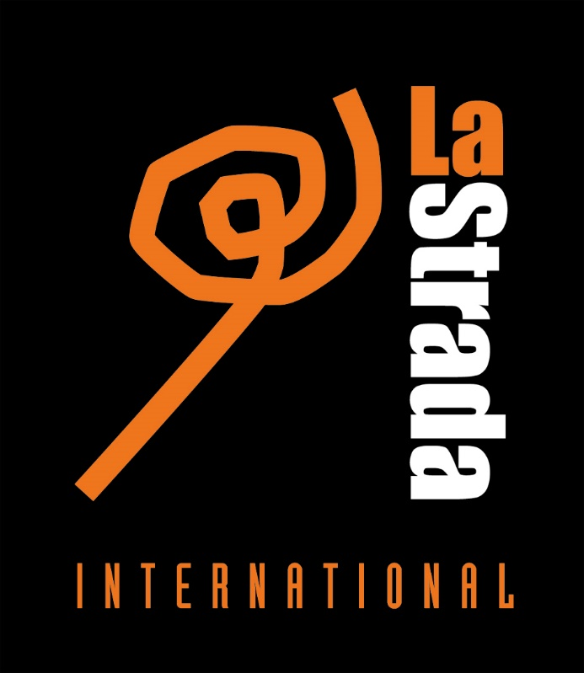

LA STRADA INTERNATIONAL
EUROPEAN NETWORK AGAINST TRAFFICKING IN HUMAN
ANNUAL SUMMARY REPORT 2017

The work of La Strada International in 2017 has been supported with the financial support of the European Commission, the Dutch Ministry of Foreign Affairs and a donor that wants to remain Anonymous (Anonymous donor). The activities of the La Strada International members are further supported by numerous national and international donors. The contents of this publication is the sole responsibility of the author; none of the donors are responsible for any use that may be made of the information contained herein. The contents of this publication may be freely used and copied for educational and other non-commercial purposes, provided that any such reproduction is accompanied by an acknowledgement of LSI as the source.
Text: La Strada International
Amsterdam, May 2018
www.lastradainternational.org

LA STRADA INTERNATIONAL
The International La Strada Association (known as La Strada International/LSI) is a leading, value-driven European NGO Network that aims to achieve a world without trafficking in human beings by promoting the respect for human rights through policy, advocacy, information and research and coordinated action.
LSI develops the capacity of the member organisations and other stakeholders to improve services to trafficked persons and at-risk groups and empowers them to have access to and exercise their rights. Currently, La Strada International is formed by eight member human rights organisations from Belarus, Bulgaria, Czech Republic, Macedonia, Moldova, the Netherlands, Poland and Ukraine. Next to the members organisations, La Strada works with close partner organisations in Europe, who are united in the LSI NGO Platform - United against trafficking in human beings.
Currently, LSI’s NGO Platform – United against Human Trafficking in Europe - comprises 29 organisations from 24 European countries. All independent, non-governmental organisations (NGOs) in Europe that work from a grass-roots level, providing direct support to trafficked persons. With these organisations, we share values such as the human rights approach to anti-trafficking strategies and a non-abolitionist view on sex work. We cooperate on projects on specific rights issues, such as compensation and awareness raising. The international secretariat also provides services to partner organisations such as capacity building and trainings. The International Secretariat undertake activities directed at international networking, advocacy and public relations, and is responsible for developing and maintaining relations with national and international government structures and other relevant stakeholders including international organisations, NGOs and civil society networks. The secretariat further works on data collection, registration and information provision and capacity building for the member organisations. The LSI Secretariat prepares Assembly and board meetings and is further responsible for coordination of the implementation of common strategy and action plans. Additionally several international projects are coordinated by the International Secretariat.

HUMAN TRAFFICKING IN EUROPE
Human trafficking1 is a serious human rights violation, and combating this crime remains a priority in Europe today. Several Central and Eastern European countries, in which La Strada operates are faced with political, social and economic instability, bureaucracy and corruption. La Strada countries generally face high levels of unemployment. This, combined with the lack of adequate social welfare systems forces people to move or migrate internally or abroad. Next to economic reasons, people also leave because of corruption or discrimination or other serious human rights violations including armed conflict outside and in Europe, like currently In Ukraine. Human trafficking reflects the poor social and legal position of individuals in many countries. Human trafficking in particular affects people working at the margins of the formal economy, with irregular employment or migration status. Human trafficking is not a static phenomenon; changes and new trends in trafficking practices are discernible over time. There is an increasing recognition throughout the world that it is not only women and children who fall victim to traffickers. Trafficking of adult men seems to be primarily for the purpose of labour and thus links closely with another trend already noticeable in the last years; an increase of trafficked persons exploited in industries other than the sex industry. Such industries known to be vulnerable for human trafficking, forced labour and exploitation are domestic work, sweatshops, catering and restaurants, construction, agricultural work, entertainment industry and the commercial marriage market. Despite the difficulty to accurately determine the scale of the issue, it is evident that thousands of people are being trafficked within, to and from Europe every year.
La Strada International has consistently advocated caution and critical awareness when using data to measure human trafficking, including using data to justify the development of measures and policies. Data collection on such a complex phenomenon as human trafficking has proven to be extremely difficult and inconsistent. Although many reports that present data do give out warnings not to consider this data as the ‘absolute truth on human trafficking’, they have been endorsed by many but at the same time criticised by others. 1Article 3, paragraph (a) of the Protocol to Prevent, Suppress and Punish Trafficking in Persons defines Trafficking in Persons as the recruitment, transportation, transfer, harbouring or receipt of persons, by means of the threat or use of force or other forms of coercion, of abduction, of fraud, of deception, of the abuse of power or of a position of vulnerability or of the giving or receiving of payments or benefits to achieve the consent of a person having control over another person, for the purpose of exploitation. Exploitation shall include, at a minimum, the exploitation of the prostitution of others or other forms of sexual exploitation, forced labour or services, slavery or practices similar to slavery, servitude or the removal of organs.
ADDRESSING HUMAN TRAFFICKING
La Strada International recognises trafficking in human beings as a very complex phenomenon and sees the need for a broad understanding of the intersections of migration, development, labour market and social policies in trafficking in human beings. Human trafficking has its roots causes in global inequality, (gender)discrimination, oppressive social structures, exclusion, poverty, political instability and (armed) conflicts leading to large groups of people, including migrants and refugees, to seek work, safety and stability away from home. These root causes, next to the demand for cheap labour and products, globalisation and deregulation of labour, have made workers more vulnerable to exploitation and abuse. The growing anti-migration sentiments and even xenophobia by both public and politicians in many countries could cause further discrimination of migrants leading to condoning situations of exploitation and abuse. Policy measures – taken within the criminal justice framework - are often still only focussed on fighting crime, restricting migration and repressing prostitution, harming the rights of trafficked persons and vulnerable groups. To end trafficking in human beings the structural root causes need to be addressed. We understand that by doing so we are also targeting powerful economic, political, social and cultural structures and interests. Being critical does have its effect on the independent position of NGOs in certain parts of the region, who often find themselves under attack. On the other hand we see more and more businesses and consumers being critical about exploitation in their supply chains and in the products they buy. It is crucial to embrace these efforts for (corporate) social responsibility and are looking for ways to engage in these movements for structural change. La Strada’s core work is dedicated to the rights of trafficked persons and affected groups through awareness raising, prevention, assistance and advocacy. At several occasions in 2017, LSI – together with others - raised concern about the new EU Agenda on Migration, as well as other political, social and economic changes, reported by La Strada members, impacting negatively on human rights, the human trafficking situation and La Strada’s work. Positive changes reported related in particular to revision, signing, ratification or adequate implementation of (anti-trafficking) legislation, however LSI members and partners also continue to report inadequate (implementation of) legislation on human trafficking. Further, the increasing abolitionist voice in Europe, which calls for criminalisation of prostitution, which LSI opposes, is a continuous challenge, requiring quick actions and response to measures taken at EU and national level.

LSI STRATEGIES FOR 2016 – 2020
In 2015 a new Strategic Plan for 2016 – 2020 was adopted, after a thorough evaluation of complemented actions and outcome of the Strategic Plan for the period 2012 – 2015. This new Strategic Plan presents the key strategies that LSI will employ in the coming years to ensure that trafficked persons’ rights are recognised, respected and realised. La Strada’s strategies include providing access to services and justice, advocacy for change and building partnerships and movements. In order to ensure that our work is effective and to obtain a clear understanding of the effectiveness and impact of our work, La Strada tries to better monitor and evaluate its activities as an integrated part of our work and aims to develop a Europe-wide NGO monitoring system on implementation of rights. It further supports the development of new and adequate, qualitative and sustainable services based on needs and quality standards set. La Strada International aims to strengthen the organisation, believing that it can take up an even more leading role in the anti- trafficking field, by building the capacity of grass-roots on issues such as data protection, access to justice and compensation, helplines and monitoring; human rights laws and monitoring bodies. But also by representing them at the international political level, while ensuring that their concerns and recommendations based on experiences of trafficked persons are heard. In 2017 LSI increased its visibility by putting more focus on its social media presence and international campaigns, while also collecting information, conducting research and reporting to raise attention for concerns and recommendations. In order to ensure strong European cooperation and a strong and critical voice of rights-based anti-trafficking organisations, LSI continues to discuss the needs and options for the revision of the structure of both the network and the platform and the role of the LSI secretariat. As expressed and supported by members of LSI board and Assembly, extension of the network is needed to operate effectively at the European level and to ensure a stronger NGO voice. LSI has not only invested much in the strengthening of the LSI NGO platform and cooperation among members, but also in become more financial sustainable to remain independent, which means looking for other donors and alternative financial support. As we believe in the flexibility and stability of grass-roots work of independent NGOs and the strength of joint actions and active cooperation, La Strada builds bridges to social movements and donors working on human, women, migrants and labour rights. We are critical and determined in our advocacy for rights and we are open and inviting to seek opportunities to work side by side with international organisations in a collective efforts for change for a just and fair world, including developing strategies to engage with businesses and public on corporate social responsibility.

LSI PROJECTS IN 2017
In 2017, LSI was part of one international research consortium DemandAT coordinated by ICMPD in Vienna, Austria. The DemandAT research, which continues until June 2017, addresses the challenge of understanding demand for trafficking in human beings and analyses the policy and practical measures that can influence this demand. LSI helped to organise the final conference of DEMANDAT in Brussels, Belgium. All project documents and deliverables are still available at the DEMANDAT website, www.demandat.eu
In September 2017, LSI started the project Rights at Work, tackling labour exploitation in all economic sectors in Poland, Romania and Bulgaria. This project in particular aims to increase identification and referral of cases of labour exploitation of migrants via research, capacity building and closer cooperation between trade unions, anti-trafficking NGOs and migrant right groups and advocacy towards governments and the private sector. The project, funded by the Dutch Ministry of Foreign Affairs, continues until August 2018.
The final report will be published in the end of 2018, beginning of 2019.

JUSTICE AT LAST – European Action for Compensation for Victims of Crime
In October 2017 La Strada International further started the project Justice at Last – European Action for compensation for victims of crime.
Evidence obtained from earlier research shows that very few victims seek compensation, and that among those who do, even fewer receive a compensation payment. Obstacles to accessing and obtaining compensation include a lack of awareness among police and the judicial system, lack of access to legal aid and adequate information for victims, and the postponement of trials and long duration of criminal and civil proceedings. Another obstacle, in the case of foreign victims, is the return or deportation to their country of origin before a verdict is reached. Even when compensation has been ordered, barriers exist that leave victims without payment. These barriers include that victims rarely have the means to ensure the compensation order is enforced. But also that the perpetrators are not found, are not prosecuted, have moved their assets abroad, or have declared themselves bankrupt to avoid confiscation of their assets and having to pay compensation. Access to State compensation funds may be hindered as well, for instance due to a lack of residence status, lack of information, lack of means, and lack of access to legal aid. In short, many barriers prevent victims from claiming and obtaining their rights, including the right to compensation.
The project Justice at last – European action for compensation for victims of crime aims to enhance access to compensation for trafficked persons and victims of related crimes. For victims of crime, the right to compensation is recognised and well established in EU legislation. Nevertheless, many barriers remain that prevent these victims from actually accessing this right. This project is partly funded by the European Union’s Justice Program (2014-2020). The project aims to identify and analyse remaining barriers to access remedies, as well as needs and best practices on how to overcome such barriers. It further intends to equip professionals with knowledge and skills on claiming and providing assistance for obtaining compensation and to raise awareness amongst professionals, policy makers, service providers and victims of crime in Europe.
Project activities
Project activities include the identification and legal analysis of compensation claims; assessments of gaps related to victims’ needs, referral, and receipt and payment of claims; international and national trainings, seminars and focus group meetings and a European information campaign. This project is partly funded by the European Union’s Justice Program (2014-2020). The project is coordinated by La Strada International and implemented in cooperation with partners in Bulgaria (Animus Association), Czech Republic (La Strada), Spain (SicarCAT and Esperanza), Germany (KOK), Austria (LEFO), The Netherlands (FairWork), Ireland (MRCI), Romania (Adpare), Macedonia (Open Gate/La Strada) and Serbia (ASTRA). These project consortium partners are also the partners who will implement the Know your Rights – Claim Compensation Campaign.

LOBBY AND ADVOCACY
The lobby and advocacy work of LSI is planned according to LSI’s strategic plan and annual Action Plan and its separate lobby plan, but also involves ad hoc work such as reacting to new European developments, actions and campaigns, or supporting the LSI members with reacting to relevant national developments.
Lobby focuses on more effective implementation of legislation, accessibility of assistance to both citizens and foreign national victims of human trafficking and adoption and/or implementation of an NRM. Among the main challenges the LSI members mentioned were the following: victim identification, assistance and compensation, identifying factors of vulnerability and vulnerable groups, coordination between service providers and law enforcement, streamlining the NRM and timely implementation of legislation. In 2017, LSI intensively lobbied the EU, Council of Europe, and to a lesser extent also addressed the OSCE and the UN, providing specific recommendations to improve the protection and observance of the rights of trafficked persons, migrants and other groups vulnerable to human trafficking. In 2017 the following events were attended by LSI secretariat:
- 21 January 2017 – International (closing) conference of Dutch organisation TIE on international ‘grass root’ trade union work’. (TIE and SOMO)
- 5 April 2017 - OSCE AECT meeting (International counter trafficking stakeholders meeting for AECT members only) – Including meetings with IOM, Council of Europe and OSCE (LSI)
- 7 May 2017 - labour exploitation and the role of the business sector - organised by OSCE in Belgrade (presentation Animus on labour exploitation in Bulgaria)
- 9 & 10 May 2017 - Final conference DemandAT project (addressing demand for human trafficking), Brussels, Belgium – meeting with several European stakeholders including ILO Brussels and ITUC in Brussels. LSI shortly presented the RAW project.
- 12 - 13 May 2017 - Platform for International Cooperation on Undocumented Workers (PICUM Annual meeting) – working group on fair labour
- May 2017 – Exchange meeting with NGOs for EU Civil Society Platform, Brussels
- 13 June 2017 – Consultation seminar/round-table “Warsaw, Poland - meeting with researchers of Warsaw University working on labour exploitation.
- 29 – 30 June 2017 - Budapest, Hungary - European and Central Asia consultations related with SDG 8.7 on forced labour, child labour, THB – by ILO Alliance 8.7-
- 17-21 August 2017 conceptual clarity trainings on concepts modern slavery, forced labour and human trafficking organised by GAATW in Bangkok, Thailand.
- 29 September 2017 – International Expert Round Table in Vienna at the House of the European Union - Vienna Austria - LSI provided a presentation on labour exploitation and demand, referring to the RAW project findings.
- 16 October 2017 - PICUM working group meeting Fair Labour
- 23 – 27 October 2017 - La Strada General Assembly meeting and NGO platform (25 - 27 October), Skopje Macedonia. RAW project findings shared with NGO platform.

